**Administration Manual**

|  |  |  |
| --- | --- | --- |
|  |  | |
| **Made by:** | **CinemaSea**  David Löffler  Marek Szeles | |
| Version: 1.0. | |  |
| Date: 16.5.2016 | |  |

**Contents**

1 Logging into CinemaSea 3

2 Home panel 4

3 Personalities 5

3.1 Adding personalities 6

3.2 Editing personalities 7

4 Movies 8

4.1 Rating Movies 9

4.2 Adding movies 10

4.3 Editing movies 11

5 Reload 12

# Logging into CinemaSea

After starting up CinemaSea, you will see a login screen, where you can login after entering your Username and Password by hitting the button “SIGN IN”:

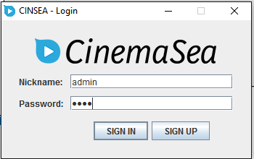

# Home panel

After logging in, you will see the CinemaSea welcome page, the home panel:

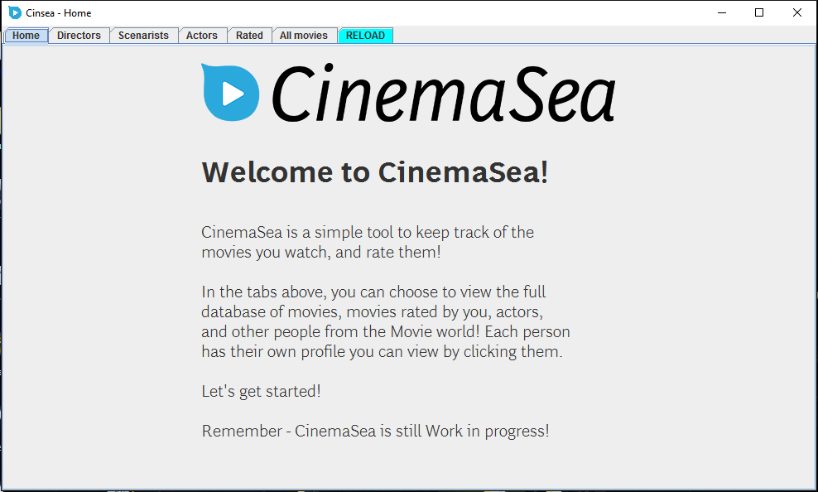

On the top menu, you can pick the different views of the program – different personalities, and movies. There is also a “Reload” panel.

# Personalities

The “Directors”, ”Scenarists” and “Actors” panels represent tables with the different personalities:

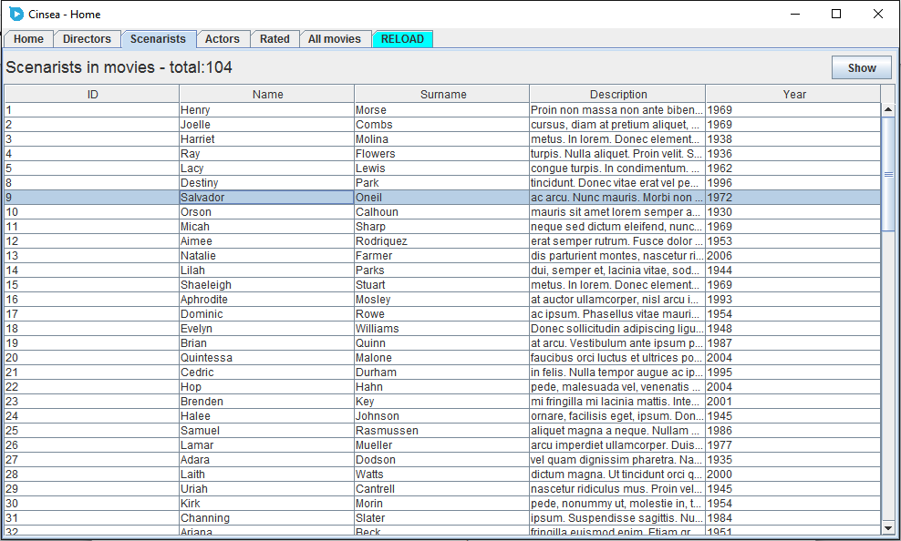

You can view details about the different personalities by selecting their row in the table and clicking on the “Show” button:

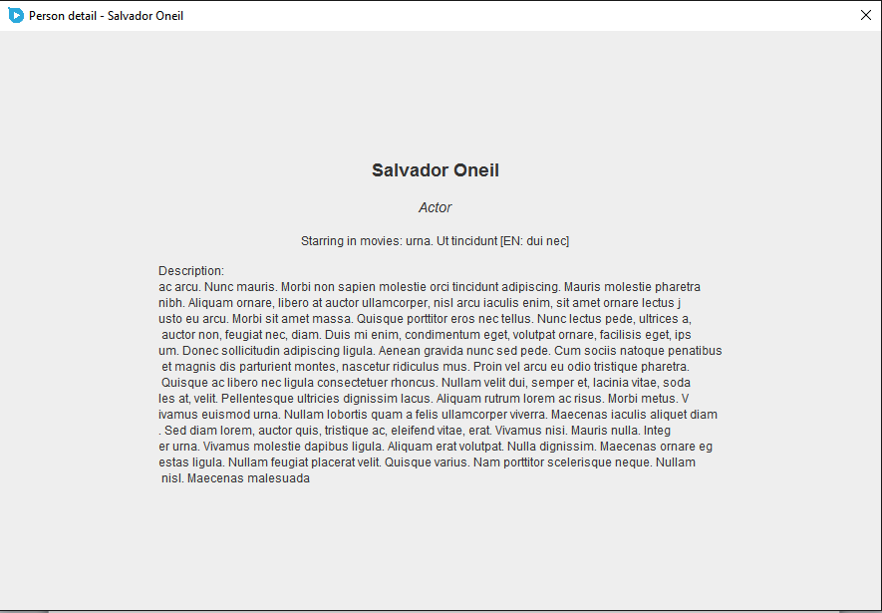

## Adding personalities

You can add new personalities to the database by clicking on the “Add” button while on one of the personality panels.



After filling in the necessary information about the personality, you can add it by pressing “Insert”:

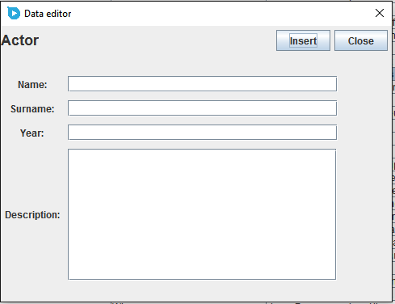

The successful insertion will be confirmed:

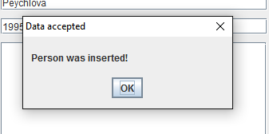

## Editing personalities

You can edit personalities in the database by clicking on the “Edit” button while on one of the personality panels, while having a person selected in the table.



An edit window will pop up:

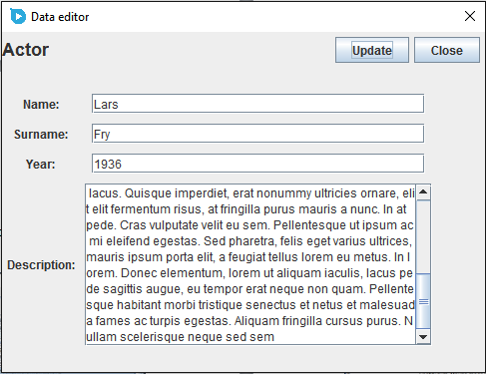

You can confirm the edits by pressing the “Update” button. A successful update will be confirmed:

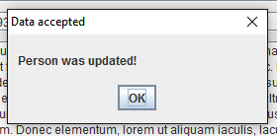

# Movies

In the “All movies” panel you can see all the movies currently in database, and in the “Rated” pane, you can see movies you already rated:

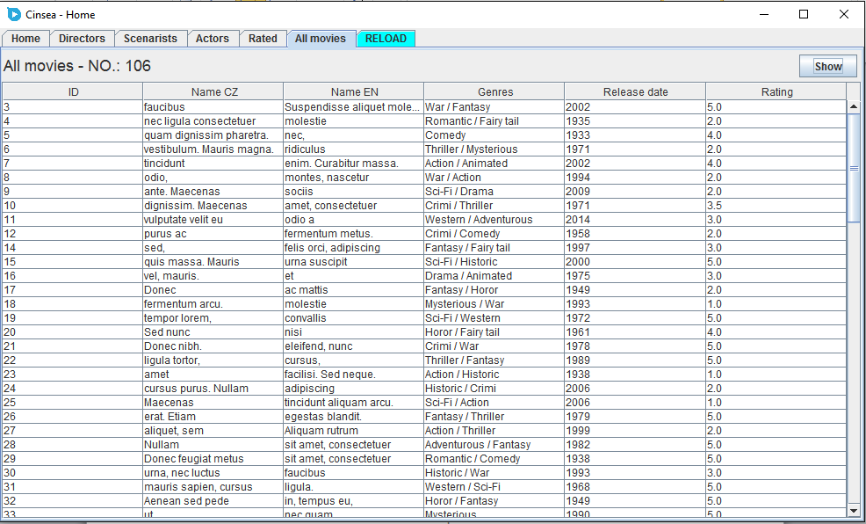

You can view details about the different movies by selecting their row in the table and clicking on the “Show” button:

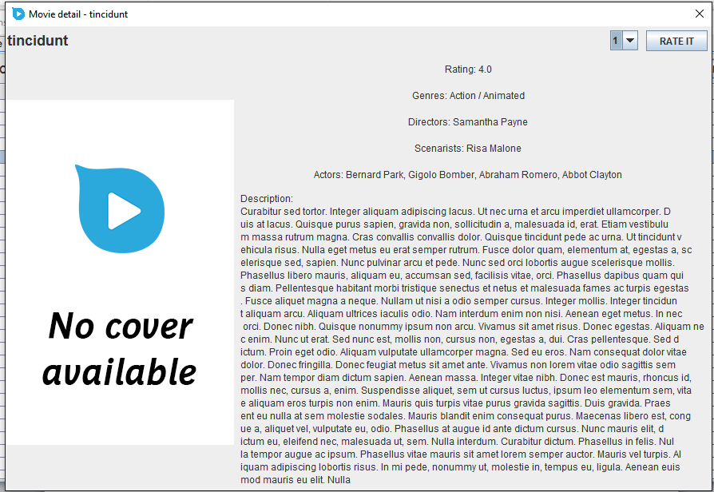

## Rating Movies

In the movie detail screen, you can pass a rating, by selecting a number and pressing “RATE IT” button in the top right corner:

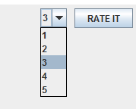

The rating will then be confirmed:

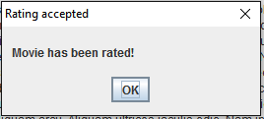

## Adding movies

C:\Users\Marek\AppData\Local\Microsoft\Windows\INetCache\Content.Word\add.pngYou can add new movies to the database by clicking on the “Add” button while on the “All movies” panel.

After filling in the necessary information about the movie, you can add it by pressing “Insert”:

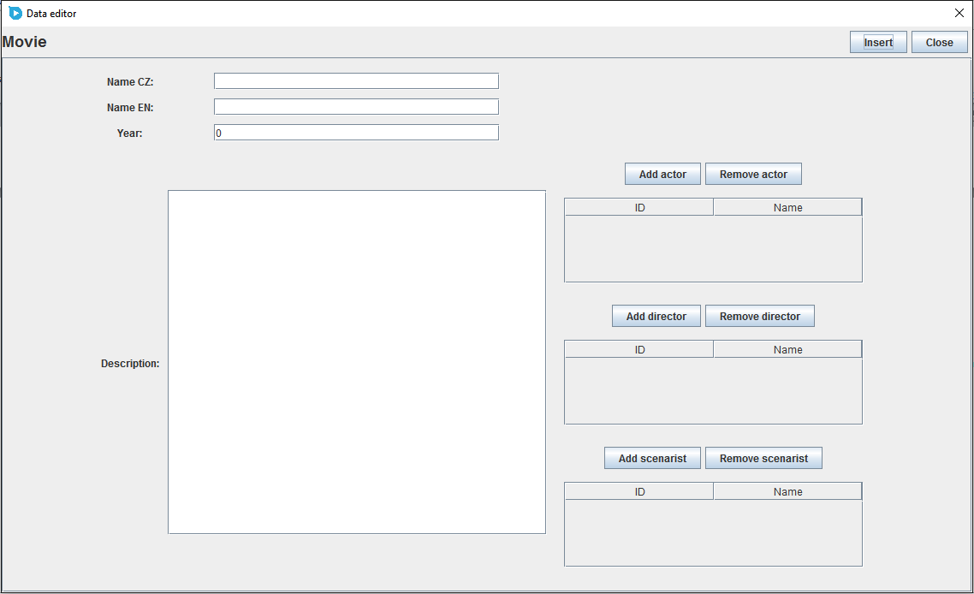

The successful insertion will be confirmed:

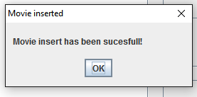

## Editing movies

You can edit movies in the database by clicking on the “Edit” button while on the “All movies” panel, while having a movie selected in the table.

C:\Users\Marek\AppData\Local\Microsoft\Windows\INetCache\Content.Word\edit.png

An edit window will pop up:

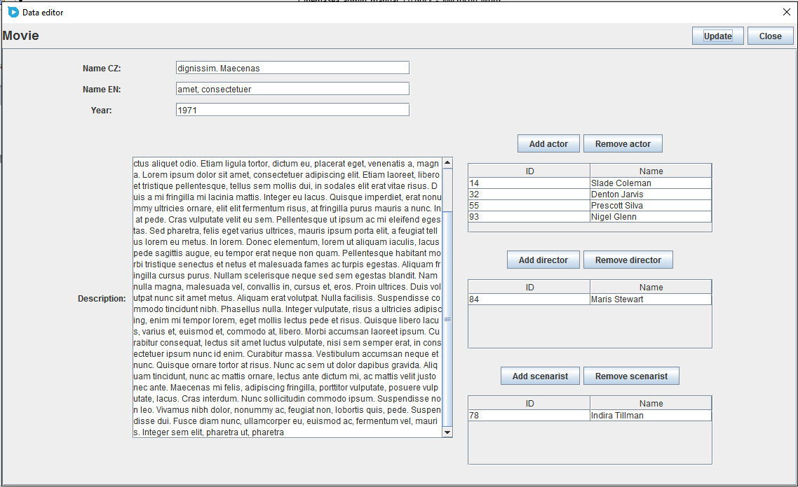

You can confirm the edits by pressing the “Update” button. A successful update will be confirmed:

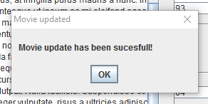

# Reload

If you click the reload pane, you can confirm to re-download the movie database to refresh the movie and personalities tables. You will be prompted to confirm this action:

